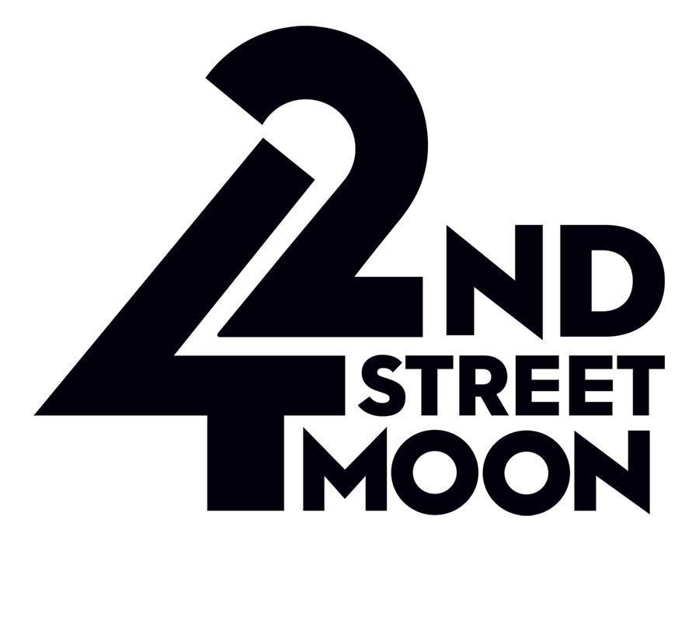
PRESS CONTACT:
Lawrence Helman 415-336-8220 (do not publish this #)
heytheresells@gmail.com

For Press Materials and hi-res color Press Photos, visit:
42ndstmoon.org/bright-star-press

https://42ndstmoon.org

https://www.facebook.com/42ndStreetMoon/

https://www.instagram.com/42ndstreetmoon/?hl=en

VIDEO CLIP: https://vimeo.com/934388521
SAN FRANCISCO’S 42ND STREET MOON
ANNOUNCES CAST AND CREATIVE TEAM
FOR THE HIT MUSICAL
BRIGHT STAR
JUNE 6 - 23, 2024
Gateway Theatre in San Francisco
Music, Book, and Story by Steve Martin
Music, Lyrics, and Story by Edie Brickell
Cindy Goldfield Director / Choreographer
Jake Gale Musical Director

Starring:
Ian Brady (Billy Kane), Carrie Lyn Brandon* (Alice Murphy), Delaney S. Dorsey (Margo Crawford), Brian Herndon* (Daddy Murphy), Alex Hsu* (Mayor Josiah Dobbs), Kim Larsen (Stanford), Melanie McBride (Lucy Grant), Mary Jo McConnel* (Mama Murphy), Anne Norland (Edna Mae), Joel Ochoa (Max/Billy Cane US), Eric Stephenson* (Jimmy Ray Dobbs), Elmer Strasser (Daddy Cane), Jay Thulien (Daryl Ames), Catherine Traceski (Flo), Elko Yamamoto (Clerk). *Members of Actors’ Equity Association

SAN FRANCISCO, CA (May 1, 2024) – San Francisco’s 42nd Street Moon (Cindy Goldfield, Interim Artistic Director) is pleased to announce the full cast and creative team for the hit musical BRIGHT STAR, Music, Book, and Story by Steve Martin, Music, Lyrics, and Story by Edie Brickell.

42nd Street Moon’s production of BRIGHT STAR is directed and choreographed by CINDY GOLDFIELD, with JAKE GALE as Musical Director. BRIGHT STAR runs from JUNE 6 - 23, 2024 (15 performances only), at San Francisco’s Gateway Theatre* - 215 Jackson St., (at Battery St.) San Francisco, 94111. The press opening is on Sat., June 8, 2024 at 6:00 pm. Show Times: Wed.- Thurs. 7:00 pm; Fri. 8:00 pm; Sat. 6:00 pm.; Sunday 3:00 pm. (Sat. Matinee June 15 - 1:00 pm). (2 Previews) Thurs., June 6 - 7:00 pm – Preview; Fri., June 7 - 8:00 pm- Preview.
Tickets $35 - $78 and can be purchased through the Box Office at 415-255-8207 or online at https://42ndstmoon.vbotickets.com/event/Bright_Star/98262
* Venue Accessibility Information - This auditorium and a restroom are ADA-accessible.

BRIGHT STAR, inspired by a true story and featuring the Tony®-nominated score by Steve Martin and Edie Brickell, tells a sweeping tale of love and redemption set against the rich backdrop of the American South in the 1920s and ’40s. When literary editor Alice Murphy meets a young soldier just home from World War II, he awakens her longing for the child she once lost. Haunted by their unique connection, Alice sets out on a journey to understand her past—and what she finds has the power to transform both of their lives. With beautiful melodies and powerfully moving characters, the story unfolds as a rich tapestry of deep emotion.
An uplifting theatrical journey that holds you tightly in its grasp, BRIGHT STAR is as refreshingly genuine as it is daringly hopeful.

BRIGHT STAR is a musical written and composed by Steve Martin and Edie Brickell. It is set in the Blue Ridge Mountains of North Carolina in 1945–46 with flashbacks to 1923. The musical is inspired by their Grammy-winning collaboration on the 2013 bluegrass album Love Has Come for You and, in turn, the folk story of the Iron Mountain Baby. BRIGHT STAR opened on Broadway in NY in 2016 and won the Drama Desk Award for Outstanding Music and is now performed world-wide. https://en.wikipedia.org/wiki/Bright_Stiar_(musical)

The cast of BRIGHT STAR features actors who play instruments on stage. (Noted in italics - after their character name, is what instrument each actor will play.) Ian Brady (Billy Kane/guitar), Carrie Lyn Brandon* (Alice Murphy /guitar; mandolin), Delaney S. Dorsey (Margo Crawford /percussion), Brian Herndon* (Daddy Murphy /guitar; piano), Alex Hsu* (Mayor Josiah Dobbs /guitar; cajon), Kim Larsen (Stanford /percussion), Melanie McBride (Lucy Grant/uk ; percussion), Mary Jo McConnel* (Mama Murphy), Anne Norland (Edna Mae / banjo-lele; guitar), Joel Ochoa (Max/Billy Cane US / guitar; cajon; snare drum), Eric Stephenson* (Jimmy Ray Dobbs /guitar; mandolin), Elmer Strasser (Daddy Cane), Jay Thulien (Daryl Ames /percussion), Catherine Traceski (Flo /percussion), Elko Yamamoto (Clerk /percussion). *Members of Actors’ Equity Association
The Band: Jake Gale (piano/various); Michael Bang (banjo); Jeff Sherman (bass); Adrianna Khoo (cello); Nina Han (violin).

To arrange an interview with BRIGHT STAR director Cindy Goldfield,
or any of the actors, please email or call publicist Lawrence Helman
heytheresells@gmail.com 415-336-8220

In addition to Cindy Goldfield and Jake Gale, the creative team and production staff of BRIGHT STAR includes Justin Kelley-Cahill (Scenic/Lighting Designer), Ashley Rae Little (Production Manager), Morgan Bright* (Stage Manager), Aero England* (Assistant Stage Manager), Jason Kraemer (Costume Designer), and Rover Spotts (Technical Director). The Band: Jake Gale (piano/various); Michael Bang(banjo); Jeff Sherman (bass);Adrianna Khoo (cello); Nina Han (violin), and the acting company!

BRIGHT STAR runs approx. 2.5 hours including one 15-minute intermission.

Tickets to BRIGHT STAR -$35 - $78 and can be purchased online at https://42ndstmoon.vbotickets.com/event/Bright_Star/98262
or by calling the Box Office at 415-255-8207 (Tues., – Fri., 11:00 am – 5:00 pm).

PERFORMANCE SCHEDULE (15 performances)
(2 Previews) Thurs., June 6 - 7:00 pm – Preview;
Fri., June 7 - 8:00 pm- Preview.
(No Press at Previews – please.)
Sat., June 8 - 6:00 pm - Opening
Sun., June 9 - 3:00 pm -Matinee;
Wed., June 12 - 7:00 pm;
Thurs., June 13 - 7:00 pm; Fri., June 14 - 8:00 pm;
Sat., June 15 -1:00 pm -Matinee;
Sat., June 15 - 6:00pm;
Sun., June 16 - 3:00pm -Matinee;
Wed., June 19 - 7:00 pm,
Thurs., June 20 - 7:00 pm;
Fri., June 21 - 8:00 pm;
Sat., June 22 - 6:00 pm;
Sun., June 23 - 3:00 pm-Matinee - Closing.

For more information, visit: www.42ndstmoon.org

42nd Street Moon tells universal stories through the production of contemporary and classic musical theatre. Moon celebrates humanity’s common heart and champions characters who sing their truth. By honoring the best of the past and providing an outlet for the voices of the present, Moon commits to a better future through our programming, education and community outreach.

THE TEAM:
Cindy Goldfield Director / Choreographer
Jake Gale Musical Director

The cast of BRIGHT STAR features actors who play instruments on stage. (Noted in italics - after their character name, is what instrument each actor will play.) Ian Brady (Billy Kane/guitar), Carrie Lyn Brandon* (Alice Murphy /guitar; mandolin), Delaney S. Dorsey (Margo Crawford /percussion), Brian Herndon* (Daddy Murphy /guitar; piano), Alex Hsu* (Mayor Josiah Dobbs /guitar; cajon), Kim Larsen (Stanford /percussion), Melanie McBride (Lucy Grant/uk ; percussion), Mary Jo McConnel* (Mama Murphy), Anne Norland (Edna Mae / banjo-lele; guitar), Joel Ochoa (Max/Billy Cane US / guitar; cajon; snare drum), Eric Stephenson* (Jimmy Ray Dobbs /guitar; mandolin), Elmer Strasser (Daddy Cane), Jay Thulien (Daryl Ames /percussion), Catherine Traceski (Flo /percussion), Elko Yamamoto (Clerk /percussion). *Members of Actors’ Equity Association
The Band: Jake Gale (piano/various); Michael Bang (banjo); Jeff Sherman (bass); Adrianna Khoo (cello); Nina Han (violin).

In addition to Cindy Goldfield and Jake Gale, the creative team and production staff of BRIGHT STAR includes Justin Kelley-Cahill (Scenic/Lighting Designer), Ashley Rae Little (Production Manager), Morgan Bright* (Stage Manager), Aero England* (Assistant Stage Manager), Jason Kraemer (Costume Designer), and Rover Spotts (Technical Director). The Band: Jake Gale (piano/various); Michael Bang (banjo); Jeff Sherman (bass); Adrianna Khoo (cello); Nina Han (violin), and the acting company!

FOR CALENDAR EDITORS:

WHAT: 42nd Street Moon presents BRIGHT STAR

WHEN: JUNE 6 - 23, 2024 (15 performances)
(Press Opening on Sat., June 8, 2024 at 6:00 pm.)
Show Times: Wed.- Thurs. 7:00 pm.; Fri. 8:00 pm.; Sat. 6:00 pm.; Sunday 3:00 pm.
(Sat. Matinee April 27 at 1:00 pm.)
(2 Previews) Thurs., June 6 - 7:00 pm – Preview; Fri., June 7 - 8:00 pm - Preview

WHERE: Gateway Theatre, 215 Jackson St. (at Battery St.), San Francisco 94111.

RUNNING TIME: The show runs approx. 2.5 hours including one 15-minute intermission

TICKETS: $35 - $78 and may be purchased online at https://42ndstmoon.vbotickets.com/event/Bright_Star/98262
or by calling 415- 255-8207

https://www.facebook.com/42ndStreetMoon/

https://www.instagram.com/42ndstreetmoon/?hl=en

For Press Materials and hi-res color Press Photos, visit:
42ndstmoon.org/bright-star-press

VIDEO CLIP: https://vimeo.com/934388521

42nd Street Moon Values
• Moon’s art and the artists who create it reflect the diversity, inclusivity, and values of our community.

• Moon honors the work of creators past and present, interpreting their work through the lens of our time, and encourages the creators of the future.

• Moon nurtures and champions the remarkable talent that the Bay Area produces.

• Moon provides a safe and welcoming place for diverse artists to create and audiences of all demographics to experience musical theatre.

###

